

Press Release

FOR IMMEDIATE RELEASE: 12/03/21

Chung-ju Binaeseom Island designated as a wetland protected area
The Ministry of Environment (Minister Han Jeong-ae) designated the Binaeseom Island in Chung-ju city, Chungcheongbuk-do province as the 28th inland wetland protected area on November 30 following Article 8 of the Wetlands Conservation Act.

Binaeseom Island is a riverine wetland and a naturally formed island in the mid-and upstream of the Namhan River with 920,484㎡ in area. The island is the only wetland protected area designated in Chungcheongbuk-do province.

Chung-ju city has been trying to preserve the area while preventing any damages by persons by designating the Binaeseom Island as a natural resting area* under Article 38 of the Natural Environment Conservation Act in September last year.

* The head of a local government may designate as natural resting areas an appropriate area of high ecological or scenic value, etc. The natural resting areas are suitable for an investigation into nature, environmental education, etc., from areas not designated by other Acts, such as parks, tourist facility complexes, natural recreation forests, etc.

It is told that the name 'Binaeseom' is originated from the Korean word "cutting off." Reeds and trees have long been grown thickly on the island, so it was needed to "cut off." The island has become famous as the filming location from the hit K-Drama Crash Landing on You with outstanding natural beauty.

Binaeseom Island maintains its naturally formed river topography with widely distributed ripples and pools*. Coarse pebbles in their upstream and sand the downstream create habitats for various wildlife species.
* Ripples refer to low water level spots, and flow is fast in the river, whereas pools have relatively higher water levels and slower flow.

The Binaeseom Island also has abundant biodiversity as it is home to a total of 865 species, including 15 endangered species such as Chinese Merganser (Grade Ⅰ), Danyang aster (Grade Ⅱ) Gobibotia brevibarba (Grade Ⅱ).

Next year, the Ministry of Environment plans to formulate and implement a 'Preservation Plan for Chung-ju Binaeseom Wetland Protected Area (2023~2027)' to systematically preserve and restore scenic views and ecosystems in the island as well as to promote it as ecotourism resources of the community.

The Ministry strives to preserve the nature of the wetland by carrying out in-depth investigations and watching illicit acts regularly, as well as providing support to install eco-trails, observatories, direction boards, information plates, and other facilities to pursue the ecological value of the wetland.

Yoo Ho, Director of Nature and Ecology Policy Division at the Ministry of Environment, said, "While preserving the natural ecosystem of Binaeseom wetland, we will provide support to become a best practice case for utilizing the wetland." He also added, "It is also believed that having ecological education and ecological visit programs connected with eco-trail (binae-gil) and the bird sanctuary observatory in Bonghwang island will help boost the local economy."

For inquiry, please contact
- Nature and Ecology Policy Division, Ministry of Environment 044-201-7220/7229

Attachment 1 |  | Scope, Value and Necessity of Designating Chung-ju Binaeseom Island as a Wetland Protection Area

□ Designating scope : Boktan-ri, Sotae-myeon and Jocheon-ri, Angseong-myeon, Chungju-si, Chungcheongbuk-do (0.92㎢)

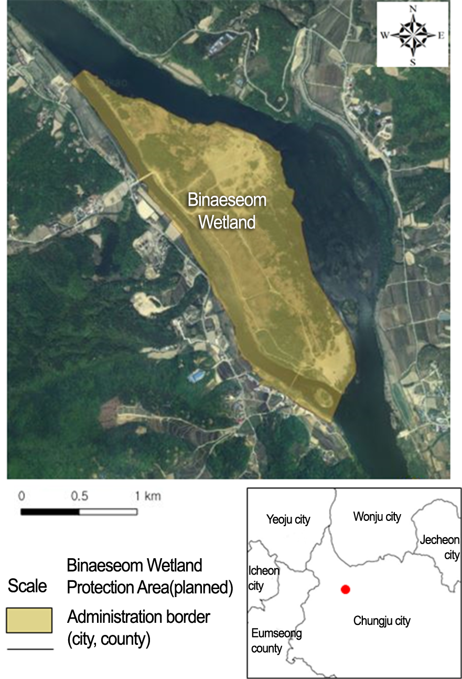

< Landscape and Species of Chung-ju Binaeseom Island >
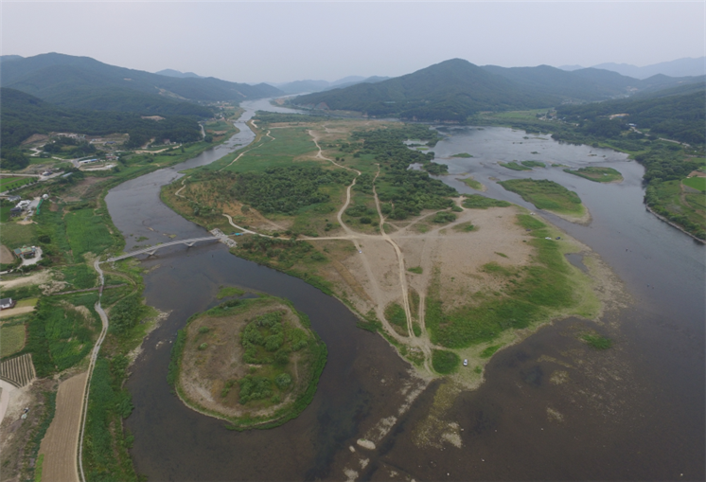 | 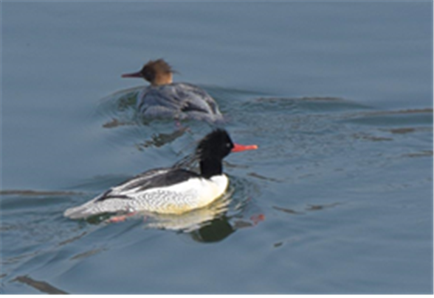
Landscape of Binaeseom Island | Chinese Merganser  (Grade Ⅰendangered species)
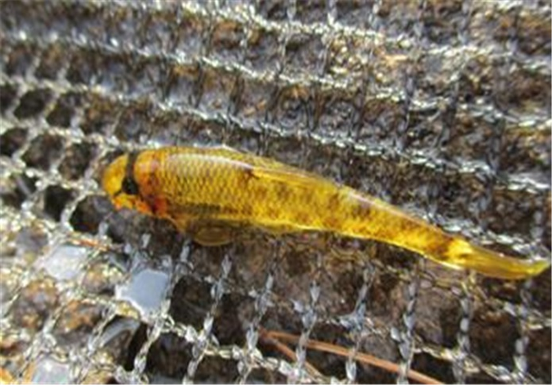 | 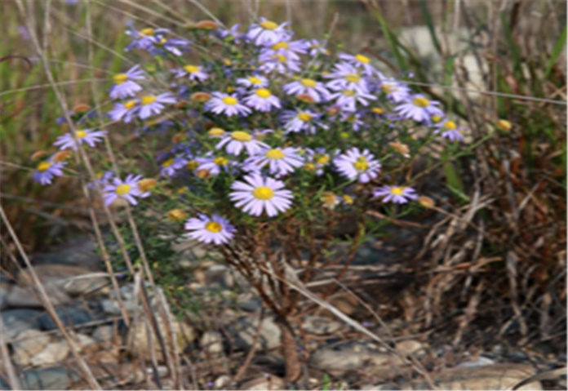
Gobibotia brevibarba  (Grade Ⅱendangered species) | Danyang aster  (Grade Ⅱendangered species)

